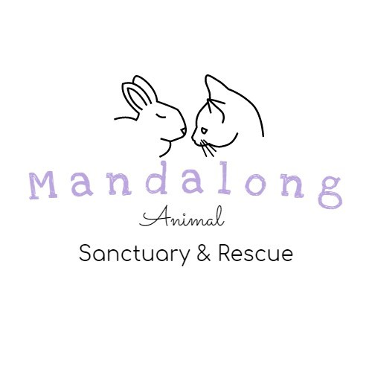
Surrender Form

Please fill out all questions as best you can so we can get to know your pet. This will help us be able to find the best possible home for them and to also get them any treatment they may need. If you need help filling out the questionnaire or need advice, please contact us via our email and we will get back to you as soon as possible.
Please be advised not all applications will be approved.
Questions and surrender forms can be sent to:
info@mandalonganimalsanctuary.org.au

Your Details:
First Name: ____________________________ Last Name: __________________________
Phone Number: ______________________________ Email: _________________________
Residential Address: _________________________________________________________
_______________________________________________________ Postcode: __________

Your Pet Details:
Pet’s name: _____________________________Type of animal: ______________________
Breed: ____________________________________________________________________
Gender: ___________________________ Age: ___________________________________

- Is your pet desexed?
  - Yes
  - No
- Is your pet microchipped?
  - Yes
  - No
- Is your pet vaccinated?
  - Yes
  - No

- How long have you owned the pet? ________________________________________________________________________________________________________________________________________________
- Where did you get the pet from? ________________________________________________________________________________________________________________________________________________
- What is the reason you are looking to surrender your pet?
________________________________________________________________________________________________________________________________________________
- Do you need this pet moved by a certain date? Please provide the date if so:
________________________________________________________________________________________________________________________________________________

Home and pet details:
- Is your pet social with children?
  - Yes
  - No
  - Unsure
- Is your pet social with strangers?
  - Yes
  - No
  - Unsure
- Are there any other animals in the home?
  - Yes
  - No
If so, please list all animals in your home and if they get along with your pet.
_________________________________________________________________________________________________________________________________________________________________________________________________________________________________
- Has your pet ever been in a fight with another animal?
  - Yes
  - No
- Has your pet ever caused injury to a person?
  - Yes
  - No
- Is your pet declared menacing or dangerous? Has your pet been investigated by any council for any reason?
  - Yes
  - No
- Does your pet have any problem behaviours?
  - Yes
  - No
- Is your pet an inside or an outside animal?
  - Inside
  - Outside
  - Both

- Is your pet toilet trained?
  - Yes
  - No
- Does your pet have any toileting issues?
  - Yes
  - No
- Is your pet scared of loud noises?
  - Yes
  - No
- Does your pet have any form of anxiety?
  - Yes
  - No
- Does your pet have any health conditions or have they had any previous procedures?
  - Yes
  - No

- Please list all relevant medical history.
________________________________________________________________________________________________________________________________________________________________________________________________________________________
- Does your pet like to be handled?
  - Yes
  - No

SURRENDER TERMS AND CONDITIONS

By submitting this surrender application form:
  - I acknowledge that Mandalong Animal Sanctuary & Rescue PTY LTD have the right to decline your application if there is no space available or your type of pet is not taken by Mandalong Animal Sanctuary & Rescue PTY LTD (e.g dogs).
  - I warrant that you are the owner of the animal and/or have the authority to surrender the animal.
  - I agree to Mandalong Animal Sanctuary & Rescue PTY LTD’s surrender process, and will undergo an interview at the discretion of Mandalong Animal Sanctuary & Rescue PTY LTD.
  - I agree that you will at all times indemnify and keep indemnified the Mandalong Animal Sanctuary & Rescue PTY LTD including its officers, employees and agents from and against any loss (including reasonable legal costs and expenses) or liability incurred arising from any claim, demand, suit, action or proceeding by any person where such a loss or liability arises from you surrendering the animal.
  - I Relinquish all ownership rights of the animal if your application is accepted by Mandalong Animal Sanctuary & Rescue PTY LTD.
  - I surrender the animal to the Mandalong Animal Sanctuary & Rescue PTY LTD if your application is accepted by Mandalong Animal Sanctuary & Rescue PTY LTD.
  - I understand that there is a $50 Surrender fee that is nonrefundable as it will be used towards costs associated with caring for your animal.
  - I verify all of the above information is true and accurate.
  - I understand Mandalong Animal Sanctuary & Rescue PTY LTD will check my references including veterinary and personal.
  - I agree to the surrender terms and conditions
Name: ______________________________________________
Signature: ___________________________________________ Date: _____________

